Pinnacle School No. 35
Staff/Parent/Student Compact
2021-2022

Pinnacle School No. 35 staff, the parents of the students participating in activities, services, and programs funded by Title I, Part A of the Elementary and Secondary Education Act (ESEA) and students in Kindergarten through Grade Six, agree that this compact outlines how the parents, the entire school staff, and the students will share the responsibility for improved student academic achievement and the means by which the school and parents will build and develop a partnership that will help children achieve New York State’s high standards. This school-parent-student compact is in effect during the 2021-2022 school year.

School Responsibilities
We, as a School, will support our students’ academic learning and achievement in the following ways:

- Pinnacle School No. 35 will provide high-quality curriculum and instruction in a supportive and effective learning environment that enables the participating students to meet New York State’s academic achievement standards as follows:
  - Teachers will use the New York State Common Core Curriculum to design rigorous and coherent instruction. Teachers will employ high level questioning and instruction will be differentiated to promote high levels of student engagement.

- Provide parents with frequent reports on their children’s progress. Specifically, the School will provide reports as follows:
  - Report Cards, Response to Intervention (RTI) Reports, and Progress Notes will be provided to parents throughout the school year to communicate individual student progress.

- Parent-Teacher Conferences will be held throughout the school year to discuss individual student’s achievement and plans for academic success.

- Provide parents reasonable access to staff. Specifically, Staff will be available for consultation with parents as follows:
  - Staff is available to meet with Parents before and after school and by appointment during school hours.
  - Parents are able to access school staff by phone, district e-mail, school website, Home-School Notebook, letters and conferences.

- Provide parent opportunities to volunteer and participate in their children’s classes, and to observe classroom activities, as follows:
  - Parents are encouraged to volunteer in classrooms, accompany classes on field study trips and participate in special activities and school-wide events. The Parent Liaison will keep parents abreast of opportunities and coordinate parent volunteer services and participation.

Parent Responsibilities

We, as Parents, will support our children’s learning in the following ways:

- Ensure the children’s prompt arrival/dismissal and daily attendance at School

- Read to and/or listen to the children read daily

- Check that the children’s homework is completed

- Restrict television to a minimum

- Provide a positive after-school environment

- Model peaceful ways to resolve conflict

- Ensure that the children get the proper rest by getting to bed early each night

- Volunteer in School

- Attend Parent-Teacher conferences

- Participate in and support School programs such as the School-Based Planning Team
  - (SBPT), Parent-Teacher Organization (PTO) and student performances.

- Support the Pinnacle School No. 35’s Buzz Expectations:

Be Respectful
Be Responsible
Be Safe

Student Responsibilities
I, as a student, will share the responsibility to improve my academic achievement and achieve the New York State’s high core standards of learning. Specifically, I will:

- Cooperate with all adults and students

- Follow the Pinnacle School No. 35’s Buzz Expectations:

          - Be Respectful
          - Be Responsible
          - Be Safe

- Solve conflicts and problems peacefully.

- Put forth good, consistent effort

- Work to the best of my ability

- Read for at least thirty (30) minutes every day outside of school time

- Complete my homework every day

- Ask for help when I need to

- Give to my parents or the adults who are responsible for my welfare all notices and information received by me from my School every day

School Staff/Parent/Student Compact
2021-2022

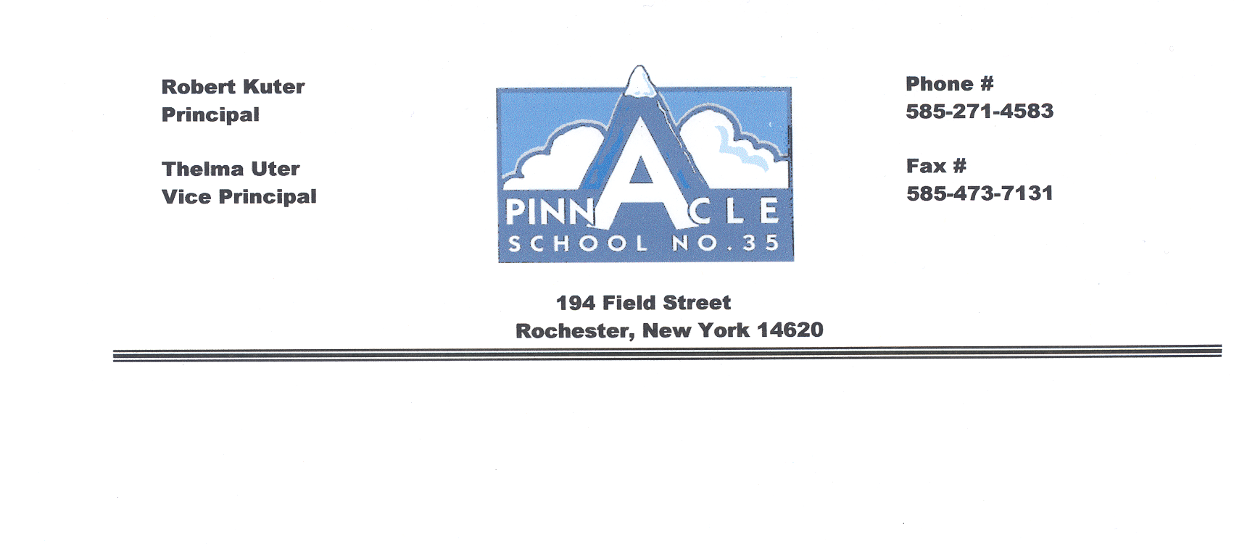

We, the undersigned, agree to work together to fulfill the goals identified in the Compact.

______________________________ ___________________
Student Date

______________________________ ____________________
Parent/Guardian Date

______________________________ ____________________
Teacher Date

______________________________ ____________________
Administrator Date

